## Process Document for Git and GitHub

1. Installing Git Bash on local computer:Download the most recent version of Git Bash for your operating system from the official Git website before you begin using it. Pay close attention to the installation instructions and make sure you don't change any settings while the installation is going on. Once the installation has completed successfully, find Git Bash in the Start menu. Open the application, then enter your email address and Git username in the Git Bash terminal. This is an important step because any modifications you make to files will be linked to the configured username and email, which will act as identity in the version control history. To set up your credentials in Git Bash, use the following instructions.

2.Create a GitHub account:This phase involves initializing a Git repository, which is a basic procedure that configures version control for a particular project or folder. To access this newly generated directory, use the `cd} command after establishing a folder named "NSAGit" on your desktop. The "NSAGit" folder is created using the `mkdir` command, and the current working directory is changed to the newly created folder with `cd NSAGit`. Then, a Git repository inside the "NSAGit" directory is initialized using the `git init` command. Git is able to trace modifications made to files within this repository thanks to this process, which also serves as the beginning of version control. Once setup, the repository will have a hidden ".git" sub-folder with all the metadata needed to track changes .

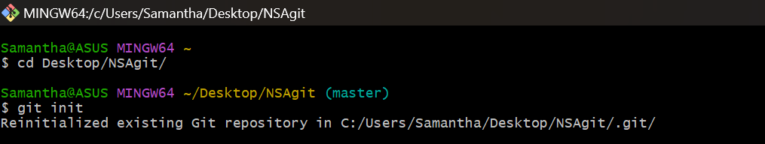

1. Add files to Repository:Move the sample RFP file to the NSAGit folder and put the RFP file in its initial form in the staging area.Apply the modifications:

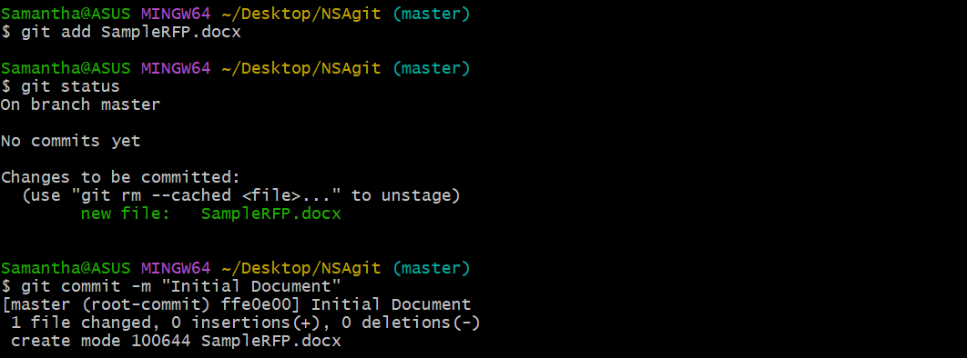

4. Modify a document located in the working directory:Access the RFP, edit as necessary, and save it.

5. Set Up the Modifications:

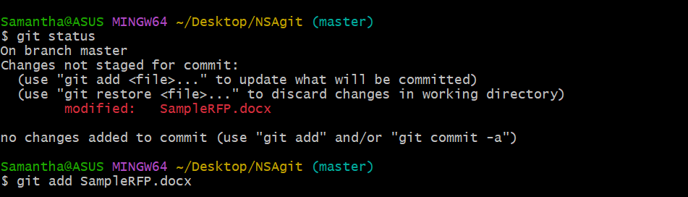

6.Modify the Changes:

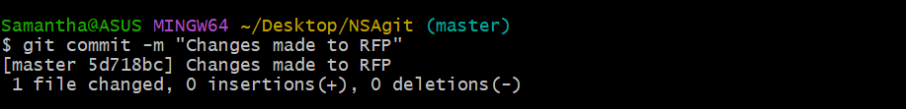

7. Revert to an earlier iteration of the software: We investigate Git's ability to roll back to earlier iterations of the document in the seventh stage. A complete history of commits, including distinct commit hashes, authors, dates, and related comments, can be viewed by using the `git log` command. This historical record acts as a guide through the development of the project. The `git checkout` command is used to choose a commit hash from the log and roll back to a certain version. To restore the "Request for Proposal Vulnerability Scanning Tool Deployment" file to its original state at the selected commit, for example, run `git checkout }. Checking the document after a rollback guarantees that any undesired changes have been removed.

Now installed Git Bash, set up a repository, added files, committed them, staged your changes, rolled them back, and successfully exited the repository.